February 2016

News & Sales Flyer

Tool and Hardware Specials:



Milwaukee

15pc black oxide drill

bit set

$13.39

12pc recip saw

blade set

338851 358874 $18.99

15AMP Circular 4-1/2” Disc

Saw 7-1/4” Grinder

$94.99 $52.99

322016 340198

30’ Powerlock Wonder

tape measure Bar

$10.99 $6.95

300935 338230

Channellock 30’ Tape Measure

$9.29

364162

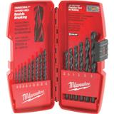

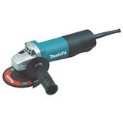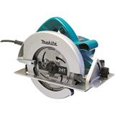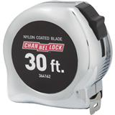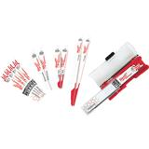



10” Marathon Circular 7-1/4” Marathon

Saw blade 40T Circular saw blade 24T

$14.49 $5.29

340456 340472

J-B Weld Coldweld Epoxy

$3.79

332925

Plumbers Torch Kit

$18.00

385808

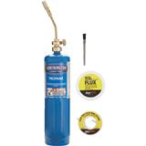

~

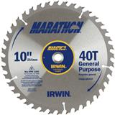

Building Material Specials:



Greenfiber Cellulose Insulation 40SF 19lb

$8.69/bg

free rental of blowing machine with purchase of 20bags!

CI

Safe‘n’Sound Insulation 3”X15.25”

$40.49/bg 59.75SF

RSSW315

Styrofoam Attic Vents 24”x48”

$.99

AV

Fiberglass Insulation

R38X24” unfaced 64SF

$35.99

U366

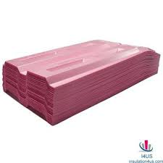

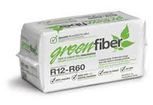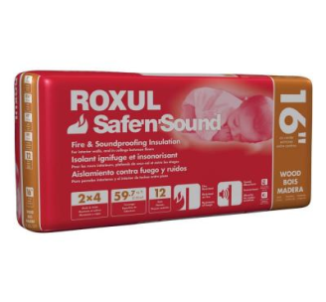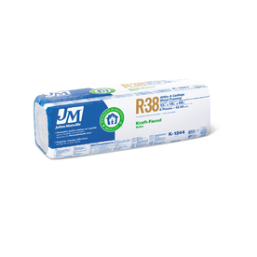

Around the House Specials:



Do-it Ice Melter 20lb.

$4.29

740906

Stain blocking Primer

1-gal

$12.99

782760

1-Gal Wet & Dry Vac

$20.00

302384

Honeywell Programmable Thermostat

$17.89

462261

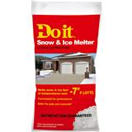

Will not harm trees, vegetation or pets.



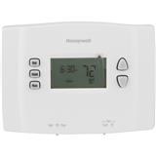

~ While Supplies Last ~



Hardware Humor:

Brain Builder: Try it! See what you come up with.

This problem can be solved by pre-school children in 5-10 minutes, by programmers-in 1 hour, by people with higher education…well, check it yourself!

8809=6 5555=0

7111=0 8193=3

2172=0 8096=5

6666=4 7777=0

1111=0 9999=4

3213=0 7756=1

7662=2 6855=3

9313=1 9881=5

0000=4 5531=0

2222=0 2581=????

3333=0

*For the answer* to this month’s

BRAIN BUILDER!

Go to

www.cavobuilderssupplies.com

or

[www.ilionlumber.com](http://www.ilionlumber.com)

(Meaningful thoughts to consider for those of us

getting closer to our “twilight”, but possibly more impactful on those who are younger and still finding their way in this world.)

“At Peace”

by Amado Nervo

As I approach my twilight, I bless you, Life, because you gave me no false hope, nor unjust labor, nor undeserved pain;

because at the end of my long journey I see that I was the architect of my own destiny;

that if, in things, I tasted the honey or bitterness within, it was because, in them, I put honey or bitterness to begin: when I planted rosebushes, I always harvested roses.

And yes, spring blossoms were followed by winter:

but you never promised me that May would last forever.

It’s true, there were long nights of pain and sorrow; but you never promised me that all my nights would be good; and indeed, some were divinely serene.

I loved, I was loved, the sun caressed my face. Life, you owe me nothing! Life, we are at peace!

Words Worth Reading:

Commodities Update:

* The price guidance we have received from USG regarding drywall pricing for the year 2016 is that at the current time there will be no increase. However, USG is saying that if there is an increase we will get a 30 day notice and that the annual increase will not exceed $30/MSF. It may be tough to bid jobs with guidance, but at least you will know the upper limit of drywall prices this year.
* USG Interiors is increasing ceiling tile prices by 5% effective February 8.
* As expected, the steel stud price increase did not occur and due to competitive pressures, manufacturers have actually decreased again.
* Fiberglass insulation will see a 6-8% increase on February 1. This is the increase that had been announced last fall and is finally being implemented now.
* Panel products: OSB is still seeing signs of consistent but small increases while SYP plywood is softening somewhat.
* Dimension lumber: both Eastern and Western SPF, are at a very low point on the price scale and would be a bargain purchase compared to the prices hoped for by the mills later this year. SYP treated numbers have been falling of late and will probably continue so for the next few weeks.

Notice:

We are planning a floor repair project at Cavo’s around the middle of February. There will be a few days that we will have much of the store stock moved outside of the office/store. We ask that you bear with us during the work and we apologize in advance for any inconvenience.

Thank you!

Two months ago I made a request for donations to the RDH12 Fund for Sight to help save the sight of Cecilia and Myles Cole, the children of our Theresa Cole and her husband Jon. I was happily surprised at the generosity of our customers, many of whom do not even know the Coles, and I thank you all sincerely. The main fundraising event held at the Tug Hill Vineyard in Lowville on November 27 was also a terrific success.

For those interested in following both the fundraising efforts and research for the cure, as it approaches clinical trials, you can log on to RDH12.org or on Facebook [www.facebook.com/eyelovececiliaandmyles](http://www.facebook.com/eyelovececiliaandmyles)

Once again, a sincere thank you to all who contributed to help improve the lives of Cecilia and Myles and all the children with their condition.